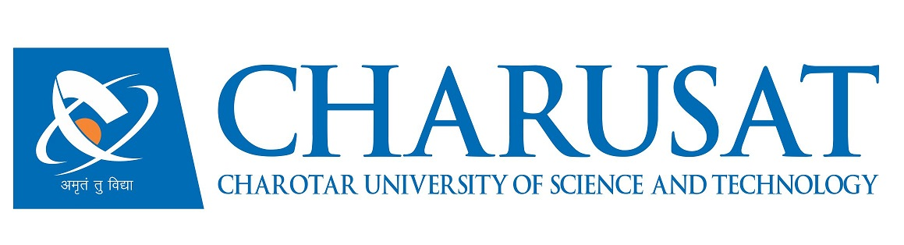

CERTIFICATE

This is to certify that the report entitled “Wireless Status Display” is a bonafide work carried out by Ravikumar Rameshbhai Patel (11CE086) under the guidance and supervision of Prof. Nishidh Chavda & Ms. Prerna Paliwal for the subject Software Project Major (CE408) of 8th Semester of Bachelor of Technology in Computer Engineering at Faculty of Technology & Engineering (FTE) – CHARUSAT, Gujarat.

To the best of my knowledge and belief, this work embodies the work of candidate himself, has duly been completed, and fulfills the requirement of the ordinance relating to the B.Tech. Degree of the University and is up to the standard in respect of content, presentation and language for being referred to the examiner.

Under the supervision of,  Prof. Nishidh Chavda  Assistant Professor  U & P U. Patel Dept. of Computer Engg.  CSPIT, CHARUSAT-Changa. | Ms. Prerna Paliwal  Technical Associate  eITRA ( eInfochips Training & Research Academy)
Dr. (Prof.) Amit Ganatra
Head, U & P U. Patel Department of Computer Engineering, CSPIT
Dean, Faculty of Technology & Engineering (FTE), CHARUSAT
Changa, Gujarat.

Chandubhai S. Patel Institute of Technology (CSPIT)
Faculty of Technology & Engineering (FTE), CHARUSAT
At: Changa, Ta. Petlad, Dist. Anand, Pin: 388421. Gujarat.

